Alex Vo

June 19, 2022

Module 4.3 – PyTech! Part Duex

ORD:

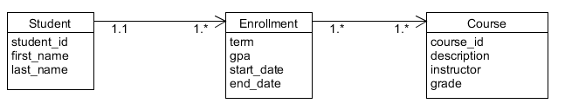

NoSQL Data Structure:

